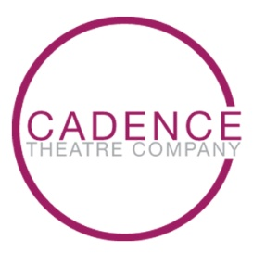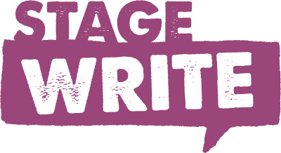

STAGE WRITE

Cadence Theatre Company’s STAGE WRITE student leadership and workforce readiness program provides Richmond and regional high school students with an opportunity to gain experience in critical thinking, problem solving, communication skills, and teamwork through writing and performing narratives that are directly relevant to the issues they face in their own lives. The program is based on pedagogy that demonstrates that performing arts training builds workforce readiness skills and lifelong personal strengths.

STAGE WRITE is led by professional teaching artists versed in the creation of original curriculum, including creative writing, oral presentation, and essential soft skills. Students will work with professionals to create work inspired by themes explored in class and in their community. Original artwork, digital photography, and video techniques will all be incorporated in the culminating performance.

STAGE WRITE student leadership and workforce readiness program was launched in October 2014. Now in its sixth year, STAGE WRITE serves Richmond and Virginia area high school students in the areas of workforce readiness, theatre performance skills and creative writing. Previous themes include Dreams, The Hero’s Journey, Community, Story and Transformation. STAGE WRITE is made possible through the generosity of Capital One, Dominion Energy, the E. Rhodes and Leona B. Carpenter Foundation, the National Endowment for the Arts, and Lynn and Jay Schwartz.

The Bridge Intro (3:56)
https://www.youtube.com/watch?v=cEuR-N1FHRg

Capital One (2:44)
https://www.youtube.com/watch?v=mge8Rn6BhmM

Transformation Finale (3:36)
https://www.youtube.com/watch?v=Tr2RxhxBNGw

